Project Design Phase-II

Data Flow Diagram & User Stories

|  |  |
| --- | --- |
| Date | 15 Oct. 22 |
| Team ID | PNT2022TMID32046 |
| Project Name | SMARTFARMER – IoT ENABLED SMART FARMING APPLICATION |
| Maximum Marks | 4 Marks |

**Data Flow Diagrams:**

A Data Flow Diagram (DFD) is a traditional visual representation of the information flows within a system. A neat and clear DFD can depict the right amount of the system requirement graphically. It shows how data enters and leaves the system, what changes the information, and where data is stored.

ADMIN

LOGIN TO SYSTEM

CHECK ROLES OF ACCESS

MANAGE FORM DETAILS

MANAGE PLANT DETAILS

FORGET PASSWORD

CHECK CRENDENTIALS

MANAGE MODULES

MANAGE GROWTH DETAILS

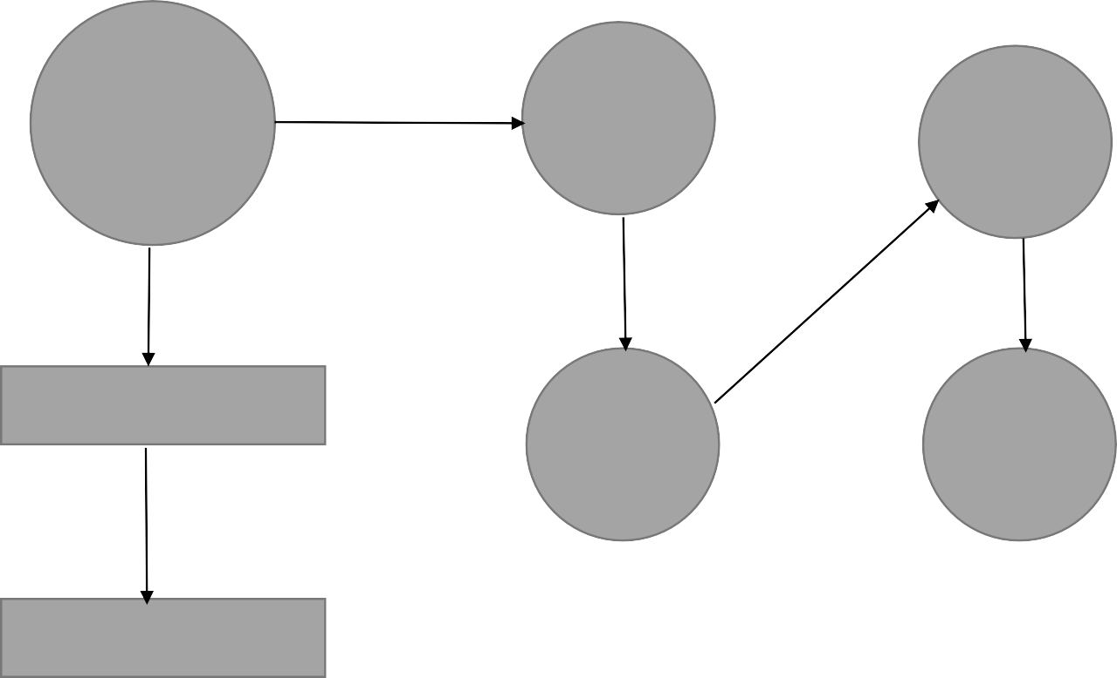

SEND EMAIL TO USER

MANAGE EMPLOYEE DETAILS

MANAGE MEDICINE DETAILS

MANAGE SYSTEM ADMIN

MANAGE USER PERMISSION

MANAGE ROLES OF USER

MANAGE REPORTS

User Stories

|  |  |  |  |  |  |  |
| --- | --- | --- | --- | --- | --- | --- |
| **User Type** | **Functional**  **Requirement (Epic)** | **User Story Number** | **User Story / Task** | **Acceptance criteria** | **Priority** | **Release** |
| Customer (Mobile user) | Registration | USN-1 | As a user, I can register for the application by entering my email, password, and confirming  my password. | I can access my account / dashboard | High | Sprint-1 |
|  |  | USN-2 | As a user, I will receive confirmation email once I have registered for the application | I can receive confirmation email & click confirm | High | Sprint-1 |
|  |  | USN-3 | As a user, I can register for the application through Facebook | I can register & access the dashboard with Facebook Login | Low | Sprint-2 |
|  |  | USN-4 | As a user, I can register for the application through Gmail |  | Medium | Sprint-1 |
|  | Login | USN-5 | As a user, I can log into the application by entering email & password |  | High | Sprint-1 |
|  | Dashboard | USN-6 | As a user, I can access the features of the application through dashboard |  | Medium | Sprint-2 |
| Customer (Web user) |  |  |  |  |  |  |
| Customer Care Executive |  |  |  |  |  |  |
| Administrator |  |  |  |  |  |  |